MONUMENTS

**MONUMENTS**

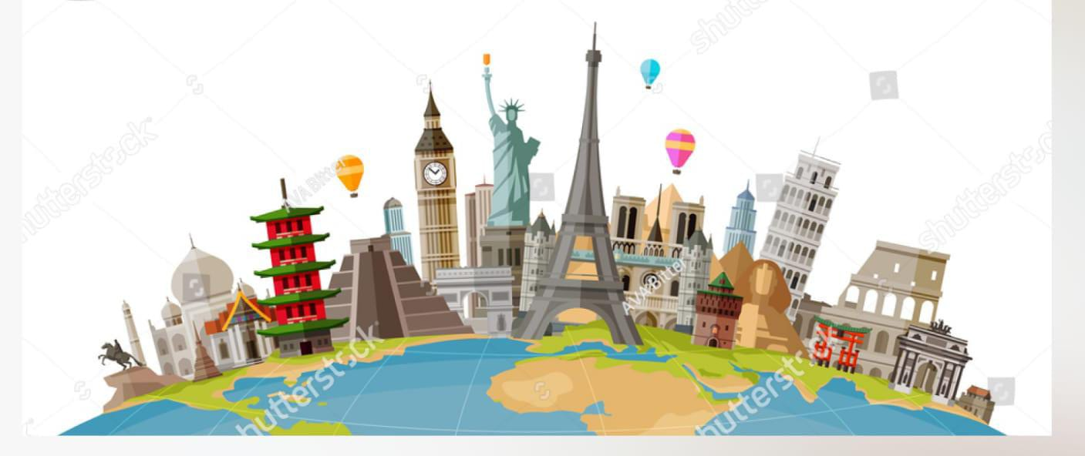

**CERTIFICATE**

This is to certify that the students

* **M TAUSEEF QASMI** Student 1525507
* **ZOHAIB UMER** Student 1509481
* **M JAZIM NOOR** Student 1512406
* **FAHAD WAHEED** Student 1508518

Of batch **PR2-202308C1** have successfully completed the given task for the topic

**FACULTY: SIR FAIZ**

**SEMESTER CPISM**

**APTECH LEARNING SHAHRAH-E-FAISAL**

**ACKNOWLEDGEMENT**

We would like to express our sincere appreciation to all individuals and teams involved in the successful completion of this IT project. Their dedication, expertise, and collaborative efforts played a pivotal role in achieving our project goals. We extend our gratitude to everyone who contributed to the planning, development, testing, and implementation phases. This project's success is a testament to the hard work and commitment of each team member, and we acknowledge their valuable contributions. Thank you for your unwavering support and commitment to excellence.

We would also like to express our sincere gratitude to Aptech Learning Centre for providing us with the knowledge, resources, and support throughout our journey. The comprehensive curriculum and dedicated faculty member Sir Faiz Ali have played a pivotal role in shaping our understanding of the dynamic field of information technology and which have undoubtedly equipped us for success in the ever-evolving world of technology.

**WHAT IS THIS E-PROJECT?**

E-Project is a step-by-step learning environment that closely simulates the classroom and Lab based learning environment into actual implementation. It is a project implementation at your fingertips. An electronic, live juncture on the machine that allows you to

* Practice step by step i.e. laddered approach.
* Build a larger more robust application.
* Usage of certain utilities in applications designed by user.
* Single program to unified code leading to a complete application.
* Learn implementation of concepts in a phased manner.
* Enhance skills and add value.
* Work on real life projects.
* Give a real life scenario and help to create applications more complicated and useful.
* Mentoring through email support.

**PROBLEM STATEMENT**

Historical Monument website will present the information about the various historic places throughout the world. The information behind this creature must be added. The information of historic places can be categorized based on zone wise (NORTH, SOUTH, WEST and EAST). The link of seven wonders, Gallery section, Contact Us, Feedback and Site Map must be added.

**Requirement Specification:**

The Web site is to be created based on the following requirements.

1. The Home Page should be created making use of Sections with a suitable logo, the header section can be added which will show different famous images of monuments.
2. The site must contain the links to navigate through any zone for the information.
3. Links of monuments can be categorized by zone wise like (East, North, West and South) apart from world wonders link can be added.
4. History behind all the monuments can be added along with the images.
5. Gallery section can be added for viewing different images.
6. Feedback must be allowed to enter by the viewer
7. Site map, Gallery, about us, Queries link, Contact us link must be added.
8. The complete historic reason and its description must be allowed to get download as pdf or doc file.
9. The advertise section of bus, flights can be included for reaching the places.

**MONUMENTS**



This website is all about world’s historical monuments. Its purpose is to give detailed information about historical monuments.

**PROJECT ANALYSIS**

|  |  |  |  |  |
| --- | --- | --- | --- | --- |
| NAME | Home  queries  About | Gallery  Site map  Zones | Feed Back  contact | DOCUMEN  TATION |
| M. TAUSEEF QASMI | Checkmark | Checkmark | Checkmark | Checkmark |
| ZOHAIB UMER | Checkmark | Checkmark |  | Checkmark |
| M JAZIM NOOR | Checkmark |  | Checkmark | Checkmark |
| M. FAHAD |  | Checkmark | Checkmark | Checkmark |

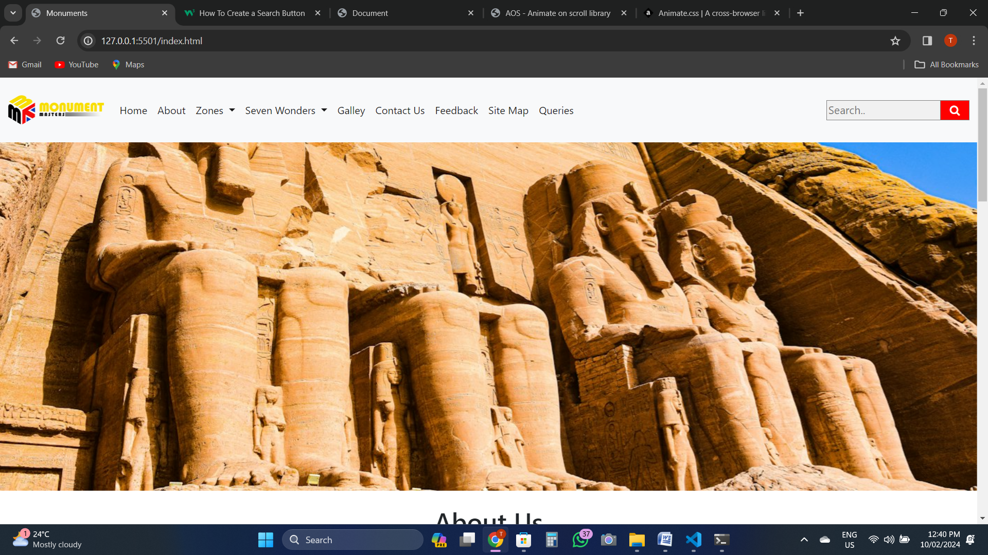**USER MANUAL**

* This is the home page of our website with monuments image, the image gets changed each time users opens the index page.

**How to use home page:**

Basically, home page is divided into two main parts: It has following main sections,

1. About Historical monuments and our introduction
2. Zones Section
3. Seven Wonders Section
4. Gallery Section

**USAGE OF NAVBAR AND FOOTER:**

Navigation bars and footers are the basic need of a website now a days so, to fulfill this particular requirement we have designed navbar and footer in such a way that user can easily navigate on our website without any problem. Further information is given below:

Navbar:

Our navbar contains 9 tabs of which Two of them shows a drop-down menu.

**ZONE TAB and SEVEN WONDERS TAB**: Zone tab enlists all four world zones while Seven wonders tab will show the names of all wonders upon click.

Image is attached below for better understanding:

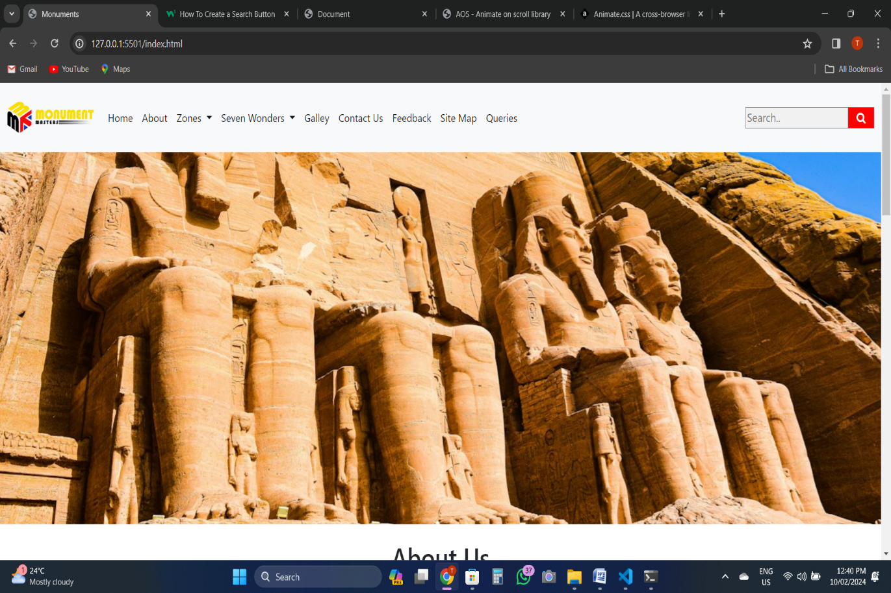

This drop-down provide details of historical monuments with respect to

their location in different zones (North, East, West and South).

This drop-down will provide user to look for any wonders information just by clicking on its name which will navigate to that wonders page.

Footer:

Our footer is divided into four parts containing our **website logo with name**, **links, quick links and contact us.** All links are hyperlinked from where you can navigate from one page to another page. Also, user can connect with us on social media.

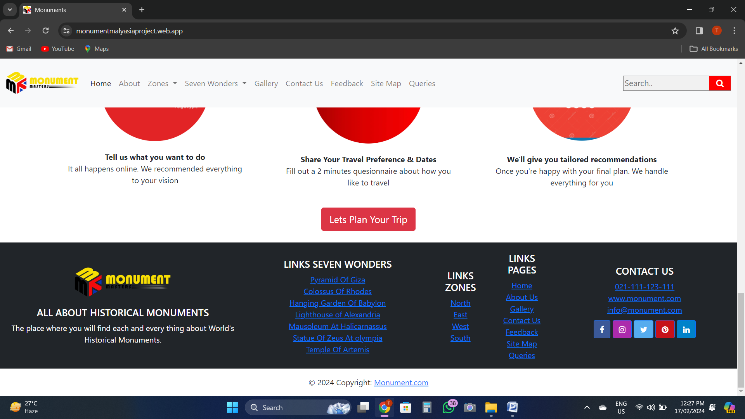

**NAVBAR-LINKS**

All the links on navbar are properly hyperlinked. There is the detailed information about:

a. Home

b. About us

c. Zones

d. Seven wonders

e. Gallery

f. Contact us

g. Feedback

h. Site Map

i. Queries

**GALLERY SECTION:**

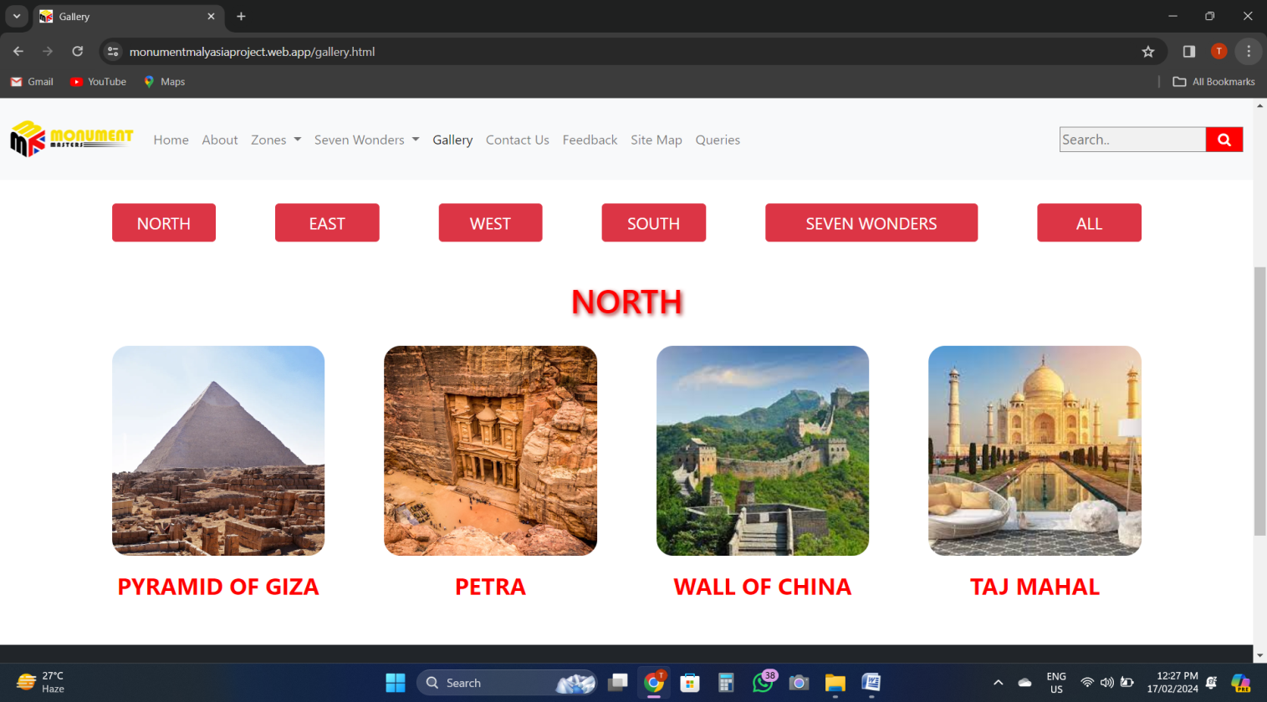The Gallery section consist of details of World’s historical monuments that are categorized according to their zones and it also has image cards of Seven wonders. There are four separate buttons for each zone and one for seven wonders that can be clicked to display image cards.

When mouse is hovered on this particular zone button, image cards of various monuments will be shown. Similarly, when user hovers mouse on Seven wonders button, their cards are displayed.

**FEEDBACK:**

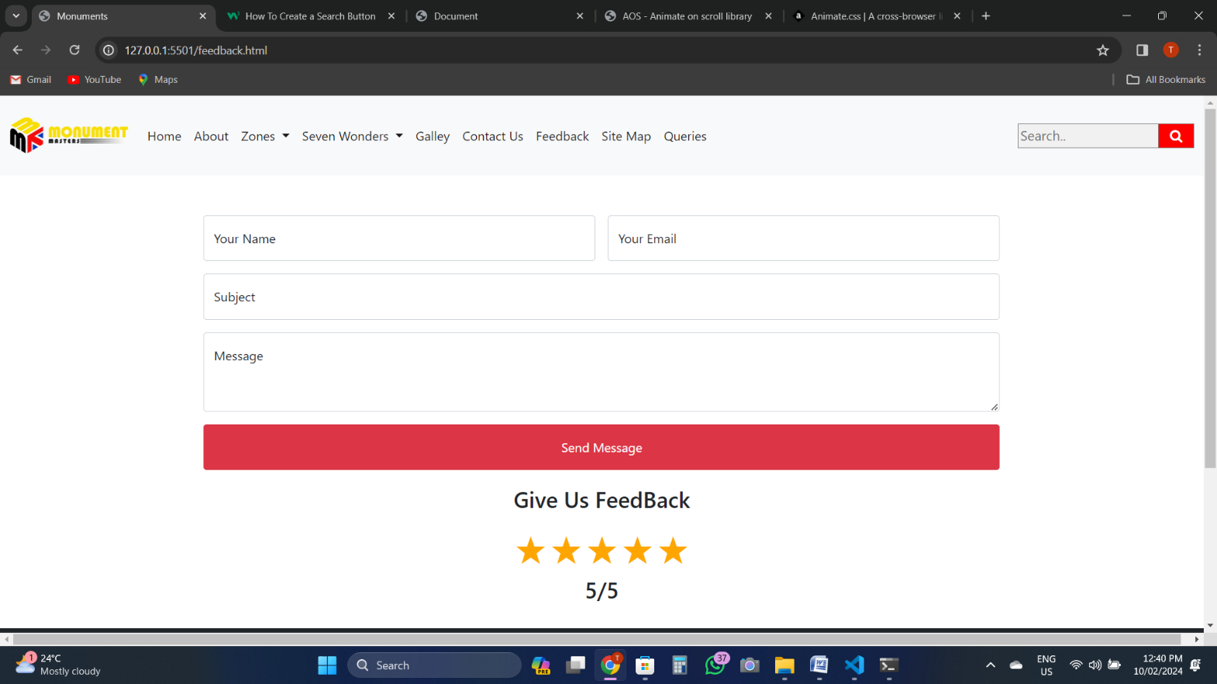The user on our website can also give his/her valuable feedback or suggestions for improvement. Also, the user can rate us about his/her experience after visiting the website. The image is attached for better understanding;

Here in this message box, the user can write the

feedback after providing his/her

Name and email for our future reference.

By clicking on stars, the user can also rate us about his/her experience on our website.

**QUERIES:**

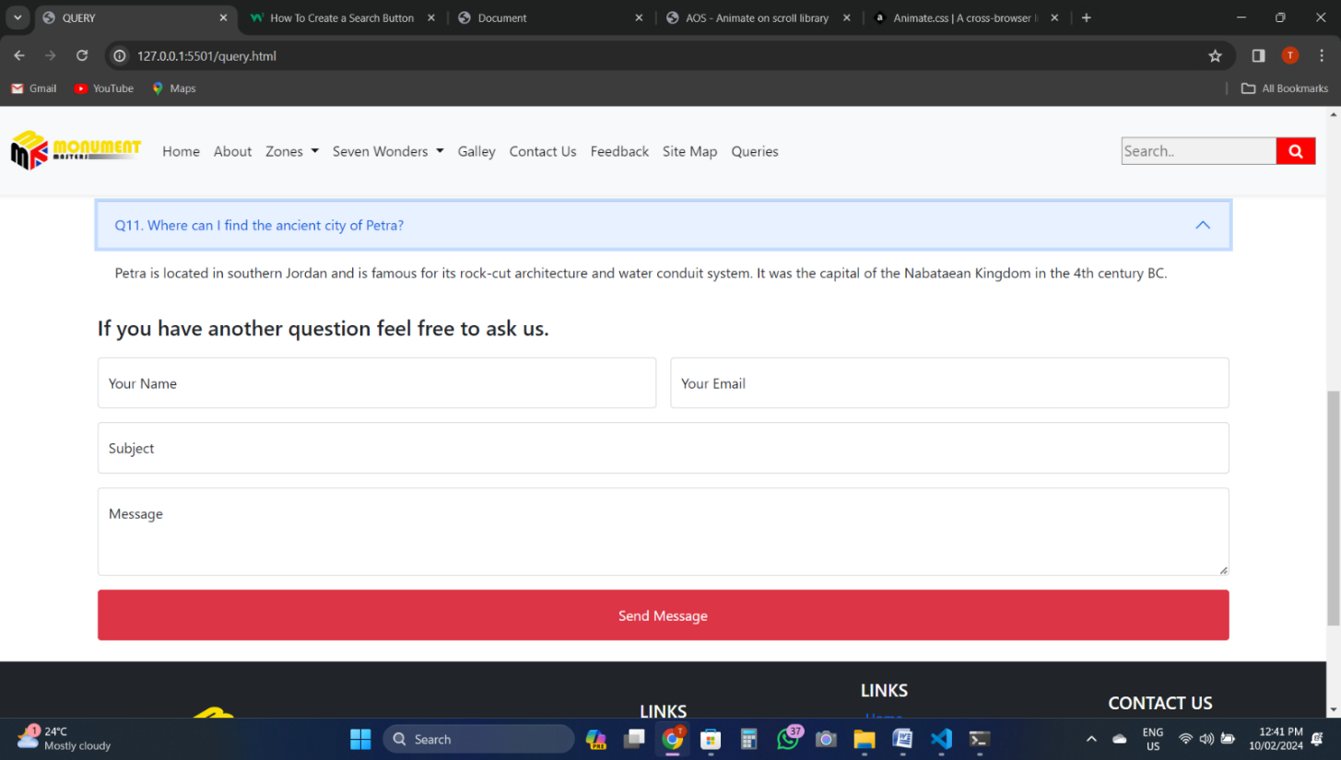In queries page, we have provided frequently asked questions along with their answers for user’s guidance. Besides this, we have also added additional feature in which user can ask any customize questions regarding anything about historical monuments. This is explained further with below image;

When user clicks on any particular questions.

Its answer is shown and gets hidden upon clicking again.

This is done by using toggle button.

This box is provided for user’s customize question.

**Home Page Source Code:**

